

**MSc Medicinal & Biological Chemistry**

**Research Techniques PGT**

**Lab Manual**

**Semester 2**

**2023-2024**

If you require this document, or any other course material, in an alternative format e.g. large print, coloured paper, etc.,

please contact the CTO

(Chemistry.Teaching@ed.ac.uk, Tel. 0131 650 4754).

**Contacts**

**Course Organiser:** Dr David August David.August@ed.ac.uk, R282

**Course Administrator:** Zoe Burger chemistry.pgt@ed.ac.uk, CTO

**PGT Lab Technician**: Stewart Franklin stewart.franklin@ed.ac.uk, NG5

**Programme Director:** Dr Chris Coxon chris.coxon@ed.ac.uk, R278

**Introduction**  **3**

**Safety** **4**

**General Organisation**  **6**

**Marking and Assessment**  **9**

**Experiment 1A**: *Welcome to the Laboratory: Synthesis of a Ni(II) Complex* **12**

**Experiment 1B:**  *Determination of metal cation content in mineral water by ICP-OES* **13**

***Introduction***

**Aims**

The aim of the Research Techniques PGT laboratory course is to build upon the laboratory techniques covered in Semester 1 and further develop students independent research and laboratory skills. This course will also provide hands-on experience with a wide range of advanced analytical instrumentation that are commonly used in any modern chemical analysis. Students will also be introduced to practical computational skills and the significant role they play in modern research methods.

**Learning Outcomes:**

At the end of this laboratory course you will be able to:

1. **Manage available laboratory time effectively**

2. **Record analytical data in a professional manner**

3. **Use a range of advanced instruments & techniques**

4. **Utilise computational methods to support practical experiments**

5. **Appreciate the importance of safety in laboratory work**

6. **Act as a confident, proficient, and independent laboratory practitioner**

7. **Design and carry out novel investigations**

***SAFETY***

1. **In general, if you are uncertain about any safety matter, consult a demonstrator or a member of staff immediately, before carrying out any procedures.**

1. **Each experiment or instrument will have been assessed according to the ALL RISKS regulations by the technicians and staff members. These assessments will be available for your inspection and you are required to read them before each session.**

1. **Safety glasses must be worn at all times. Students who normally wear spectacles are required to wear safety glasses over their normal spectacles, or to obtain a pair with toughened glass or plastic lenses and side shields. Students who wear contact lenses should advise the Technicians and/or Couse Organiser.** Contact lenses pose a particular hazard as any liquid entering the eye will penetrate behind the lens and irrigation is almost impossible. It is therefore imperative that contact lens wearers should take extra precautions to prevent chemicals from entering the eye. These precautions include the requirement to wear goggles for any experiment that may involve a significant risk of harmful chemicals splashing into the eyes. This requirement, where necessary, will be indicated on the appropriate risk assessment form. Wearers of contact lenses should preferably wear spectacles (and over-glasses) as an alternative while in the laboratory. However, if lenses are to be worn, the student **MUST** make themselves known to the technician at the beginning of the laboratory course.

1. **Students must bring their own laboratory coat which must be worn at all times when in the laboratory.** **Lab coats should be stored in the laboratory when not in use.**

1. **Smoking, eating and drinking are not permitted at any time.**

1. **Coats and bags must not be kept on the laboratory floor, as they obstruct the gangway. Lockers for use during the laboratory periods are provided in the PGT Study Room. Students are advised to bring a padlock if they wish to leave valuables in theselockers.** **All possessions are left at your own risk.**

1. **Remember that you are responsible for your own safety and for the safety of others working in the laboratory.**

1. **Take the utmost care in disposing of hazardous chemicals - when in doubt consult the member of staff. Do not dispose of organic solvents down the sink. Place such residues in the appropriate containers provided – yellow cap for chlorinated, red cap for non–chlorinated.**

1. **If you suffer from any medical condition or disability that might affect your safety or that of others in the laboratory, please inform discreetly the member of staff in charge of the laboratory.**

1. **Never work in the laboratory except during approved class hours unless specifically arranged with the course organiser.**

**Emergencies**

* + The first rule in any emergency is to alert the member of staff, a technician, or a demonstrator.
  + Report all accidents requiring First Aid (cuts, burns etc.)
  + Small fires can be smothered with a wet duster. Report all larger fires immediately.
  + If chemicals are splashed into the eyes or face, immediate action is required. Eyewashes are provided at each end of the laboratory, and you should familiarise yourself with their use.
  + Chemicals on the hands or clothes should be rinsed with water immediately.
  + If the fire alarm sounds (a continuous alarm), the laboratory must be evacuated immediately. There are fire exits at both ends of the laboratory; you should be escorted by your demonstrator to the assembly point, which is beside Brewster’s statue at the front door of the old building. If an intermittent alarm sounds, the problem is in the other building and evacuation is not necessary.
  + The nearest qualified first aid workers are:

Alan Taylor (Lab 10 – Mass Spec), Ilka Schmueser (Lab 6/73) or Jennifer Anderson (Inorganic Lab).

***General Organisation***

**Laboratory Timetable**

The Research Techniques PGT course will operate in weeks 1-10 of Semester 2. Each student will be scheduled to attend 2 sessions each week. You must attend your assigned sessions only and you must complete all of the investigations and workshops. The sessions will take place in multiple locations – please see the full timetable on LEARN for details.

**Labs for the Medicinal & Biological Chemistry PGT programme will run Mondays from 2 pm to 5 pm (14:00-17:00) and Thursdays 10 am to 1 pm (10:00-13:00).**

The Laboratory schedule consists of three sections:

* Section 1 is a 2-week rotation of four instrument training sessions. These are designed to give you hands-on training and experience with a range of advanced analytical instrumentation. This is intended to prepare you for the later investigation and your summer research projects.
* Section 2 consists of a short 2-week computational chemistry workshop and project designed to introduce you to aspects of computational chemistry that can be applied to Analytical chemistry. Computational techniques are rapidly increasing in importance in chemistry and are becoming an essential practical skill for any modern chemist.
* Section 3 is a stand-alone investigation spanning a total of 12 lab sessions. During this period, you will work in groups to investigate an aim utilising a range of laboratory techniques and analytical instruments. This builds on your experience in Semester 1 and aims to prepare you thoroughly for your summer research projects.

Throughout this course you be assigned to groups that will rotate around each of the experiments. The composition of the groups will appear on LEARN before the start of the lab. **Please note, the group assignments may change for each of the different sections.**

|  |  |  |
| --- | --- | --- |
| **Week** | **Section** | **Location** |
| **Week 1-2** | Session 1: Instrument Training | ACIS Lab |
| **Week 3-4** | Session 2: Computational Techniques | To be confirmed |
| **Week 5-10** | Investigation B: Quantification of Capsaicin | Lyon Playfair Lab |

**Attendance**

An attendance register will be strictly kept and monitored for both Safety and Visa conditions. If you are absent from, or miss a substantial part of, a particular session, please inform the lab organiser Dr David August ([David.August@ed.ac.uk](mailto:David.August@ed.ac.uk)) and lab technicians Stewart Franklin ([stewart.franklin@ed.ac.uk](https://uoe-my.sharepoint.com/personal/daugust2_ed_ac_uk/Documents/PGT%20-%20Courses/2023-24%20Timetabling/Course%20Documents/2023-24%20Lab%20Manuals%20-%20DA%20Working%20Copies/stewart.franklin@ed.ac.uk)) or Alba Navarro Rodriguez ([??](https://uoe-my.sharepoint.com/personal/daugust2_ed_ac_uk/Documents/PGT%20-%20Courses/2023-24%20Timetabling/Course%20Documents/2023-24%20Lab%20Manuals%20-%20DA%20Working%20Copies/stewart.franklin@ed.ac.uk)) as soon as possible. See below for information regarding deadline extensions and Special Circumstances.

**Demonstrators and staff**

Postgraduate demonstrators will be available at all sessions. They will instruct you in experimental techniques and provide guidance on the analysis of results. Please make use of them – they are all experienced PhD researchers within the School and have a lot of knowledge to share.

The Research Techniques PGT organiser is **Dr David August (Room 282), Tel. 0131 650 4818, E-mail: David.August@ed.ac.uk**

Expert technical support in the laboratory is provided by theACIS technician **Alba Navarro Rodriguez** ([??](https://uoe-my.sharepoint.com/personal/daugust2_ed_ac_uk/Documents/PGT%20-%20Courses/2023-24%20Timetabling/Course%20Documents/2023-24%20Lab%20Manuals%20-%20DA%20Working%20Copies/stewart.franklin@ed.ac.uk))

**Preparation**

You are asked to read the instructions for each session and view any supporting material posted on LEARN **BEFORE** attending the associated session. This will enable you to follow the practical procedures described, minimising risk and the likelihood of damage to expensive equipment. **If you are unsure about anything, please consult a member of staff, or a demonstrator BEFORE continuing.**

***Marking and Assessment***

The importance of laboratory work in the Chemistry Degree Courses cannot be overemphasised. The laboratory classes are therefore an integral part of the course and **attendance at them is compulsory. Attendance at each designated session is recorded.**

**Poor marks are invariably the result of poor attendance and/or failure to submit reports, rather than of poor performance at the bench.** Attendance and marks are therefore monitored throughout the year. Should you miss *any* laboratory class for medical reasons you must notify the Lab Organiser by e-mail to Dr David August at [**David.August@ed.ac.uk**](mailto:David.August@ed.ac.uk) who will advise on any alternative arrangements.

To pass this laboratory course you need a minimum score of 50%. To pass the taught component of the MSc, you must both 1) obtain ≥50% in 4 out of the 6 courses and 2) maintain an average grade of ≥50% across all six courses. Please see the Programme Handbooks for further information.

## Late Penalties

All assessment items will be subject to late penalties and a 5% mark penalty will be applied for every day over work is submitted after your agreed deadline. Information on the course deadlines can be found on LEARN and information regarding extension requests and Special Circumstances can be found below.

## Plagiarism

According to the University’s Examination Regulations and Guidelines: ***"Plagiarism*** *is defined as the submission by a candidate, without adequate acknowledgement, of any piece of work (e.g. results, report, written assignment, examination answer) which has been copied from the work of another person or persons. This is a* ***serious offence*** *and if detected will result in the severest penalties. It should be understood that compiling an essay by 'lifting paragraphs' from other sources (e.g. a book, the web) is an example of plagiarism. You are strongly advised to read the information given at www.aaps.ed.ac.uk/regulations/Plagiarism/Intro.htm and the web pages listed therein ".*

**Course Assessment**

This course includes a range of different assessment methods to evaluate your understanding of the methods and skills detailed in the learning outcomes as well as your ability to operate as a research scientist. Each section of the course is assessed separately and contributes varying amounts to the total course grade as detailed below.

|  |  |  |
| --- | --- | --- |
| **Section** | **Assessment** | **Percentage of Course Grade** |
| **1** | Online Multiple-Choice Quizzes | 20% |
| **2** | Computational Exercise | 20% |
| **3** | Chem. Comm. Paper Report | 50% |
| **3** | Lab Notebook | 10% |

**Types of Assessment**

* Section 1 will be assessed using a series of short online multiple-choice quizzes. This will include a short practice quiz to help get you used to the system. **Only one attempt is allowed per student per quiz** and **you must complete the quiz in one sitting**. Please make sure you have time before starting – each quiz should not take more than 30 mins. If you experience any difficulties completing a quiz – please notify the course organiser.
* Section 2 is assessed through an individual project carried out during session 4, followed by independent work, and written into a short report.
* Section 3 requires an Investigation report written in the form of an RSC Chemical Communications Paper. Details on the format and marking criteria can be found on LEARN and at the end of this document. In addition, you will also be assessed your lab book record-keeping. Further guidance on this can be found within the Investigation details.

**Recording your Methods and Results**

Recording the results and details of experimental procedures is an important part of all laboratory work. You must do as much as possible of this in the laboratory, using the lab notebook to avoid forgetting anything, but some may have to be done in your own time soon after the lab session. The major things to record are:

* **What you did** (substances, quantities, times, temperatures, simulation parameters, etc.). This includes instrument details and specific information on the set up and methods used.
* **What you observed and measured.** This could be physical observations, such as colour changes, or references to samples submitted. This will also include saving and cataloguing any data you collect.
* **What you deduced from your observations.** This may be notes to begin with, but these will eventually form the basis of you reports.

Your lab notebook will be graded during the final weeks of Investigation B and forms 10% of your final course grade. Marking criteria are available on LEARN. **Please make sure you record all of your observations in English.**

**Extensions and Special Circumstances**

Under University policy, you can apply for an extension of up to 3 days for any of the assessment exercises. You’ll need to describe the situation that has affected you and your studies, including the time you were affected and your symptoms. You can find out more and apply for an extension online here: [Extensions Explained](https://www.ed.ac.uk/student-administration/extensions-special-circumstances/students/extensions-explained). You must submit requests for these extensions BEFORE the assessment deadline.

You can also apply for Special Circumstances for any aspect of this course. You should apply for Special Circumstances if a significant life event means that you require more than a 3-day extension to complete your work, or if your situation is long-term. Special Circumstances can allow you a longer extension, it can mean late penalties are removed, or it can even result in some sections of your assessment being disregarded from your overall course mark. In the online application form you’ll need to explain the situation that affected you in detail, including when you were affected, and describe the negative impact on you and your academic work. You’ll also need to attach a supporting letter, like a letter from your doctor or a counsellor or a member of staff (if they’ve been aware of your situation).

You can read more and apply online here: [Special Circumstances Explained](https://www.ed.ac.uk/student-administration/extensions-special-circumstances/students/special-circumstances-explained).

In either case, please contact Student Support ([chemistry.studentsupport@ed.ac.uk](https://uoe-my.sharepoint.com/personal/daugust2_ed_ac_uk/Documents/PGT%20-%20Courses/2023-24%20Timetabling/Course%20Documents/2023-24%20Lab%20Manuals%20-%20DA%20Working%20Copies/chemistry.studentsupport@ed.ac.uk)) who can assist with your application an provide further guidance.

**Instrument Training Exercises**

**Section Timetable**

For this section, the class will be divided into 4 groups. Each group will be assigned to a different instrument for each lab session – rotating each new session until everyone has completed all the topics**. Please see LEARN for the group allocations.**

|  |  |  |
| --- | --- | --- |
| **Number** | **Topic Title** | **Location** |
| **1** | HPLC/UPLC | ACIS Lab |
| **2** | Akta Go | ACIS Wet Lab |
| **3** | Fluorimeter/CD | ACIS Lab |
| **4** | NMR | NMR Suite |

|  |  |  |  |  |
| --- | --- | --- | --- | --- |
| **Session** | **Group A** | **Group B** | **Group C** | **Group D** |
| **Mon 15th Jan 14-17:00** | Topic **1** | Topic **2** | Topic **3** | Topic **4** |
| **Thurs 18th Jan 10-13:00** | Topic **2** | Topic **3** | Topic **4** | Topic **1** |
| **Mon 22nd Jan 14-17:00** | Topic **3** | Topic **4** | Topic **1** | Topic **2** |
| **Thurs 25th Jan 10-13:00** | Topic **4** | Topic **1** | Topic **2** | Topic **3** |

**General Instructions**

For each lab session in this section, you will receive guidance and training in operating your assigned instrument. This is very similar to the training that any new researcher would receive when using these instruments for the first time. The training should take approx. 1-2 hours. Please use the remainder of the lab session to try operating the instrument yourselves using the test samples provided.

Remember to record all the information provided to you in your lab notebook. You need to keep detailed enough records that you can refer to them if and when you next use the instrument.

**Topic 1: (Ultra) High Performance Liquid Chromatography (UPLC/HPLC)**

**Learning Outcomes:**

* Explain the principle of liquid chromatography and separations.
* Compare and contrast HPLC and UPLC techniques.
* Know how to operate a UPLC instrument – including sample preparation, method development, sample submission and data analysis.
* Describe and troubleshoot common instrument failures.

**Pre-lab:**

Read through the information below **BEFORE** attending the associated lab session.

**Introduction:**

Ultra-Performance Liquid Chromatography (UPLC) is a powerful analytical technique used for separating and analysing complex mixtures. The ACIS lab is equipped with two of these instruments – a Shimadzu i-Series LC-2060 and a Shimadzu Nexera. Both instruments are very similar and run the same software,

High Performance Liquid Chromatography (HPLC) operates on the fundamental principles of chromatography, utilizing a mobile phase and a stationary phase within a column. The sample, dissolved in the liquid mobile phase, is injected into the system. As the mobile phase flows through the column under high pressure, the individual components of the sample interact differently with the stationary phase. This interaction leads to the separation of the components based on factors such as size, polarity, or chemical affinity. Compounds with greater affinity for the stationary phase are retained longer in the column, resulting in distinct elution times. The separated compounds then pass through a detector, generating signals that are analysed to create a chromatogram.

Ultra-High-Performance Liquid Chromatography (UPLC) is an advancement over traditional High-Performance Liquid Chromatography (HPLC). The key lies in the utilization of columns packed with smaller particles, facilitating increased resolution for the separation of closely spaced peaks and improved component identification. As a result, UPLC operates at elevated pressures, typically ranging between 15,000 to 20,000 psi. This contrasts with HPLC's lower pressure limits, which typically hover around 6,000 psi. The systems in the ACIS are mid-range instruments and usually operate at a maximum of 15000 psi. The increase in pressure allows for UPLC to use higher flow rates and shorter analysis times, significantly amplifying sample throughput. UPLC's versatility and efficiency extend across various applications, with its diminished solvent consumption aligning with environmental sustainability and potential cost savings.

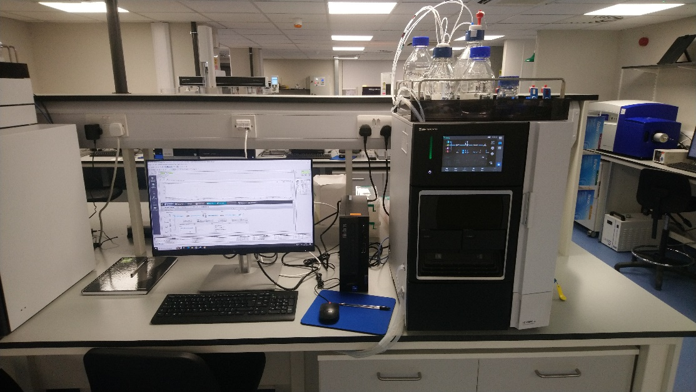

**Figure 1.** The Shimadzu i-Series LC-2060 spectrometer available in the ACIS lab.

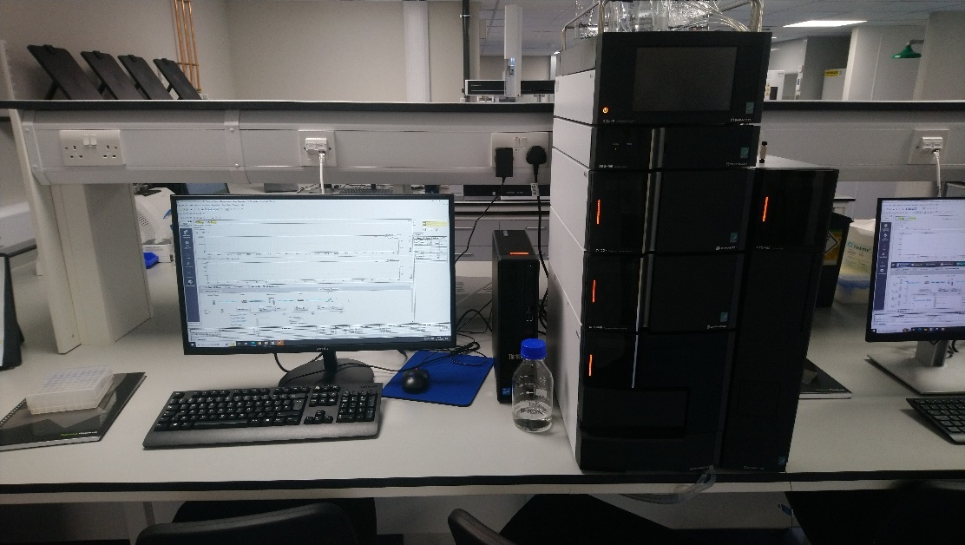

**Figure 2.** The Shimadzu Nexera UPLC available in the ACIS lab.

**Safety:**

Hazards associated with this exercise and the HPLC instrument are listed in the Risk Assessment Form available on LEARN.

**Instrument Walk-Through:**

1. **Instrument Overview:**

* Familiarize users with the components of the UPLC system, including the pump, injector, column, detector, and software interface.
* Introduce the different types of UPLC/HPLC columns and their applications.

2. **Safety Precautions:**

* Emphasise safety measures, including proper handling of solvents and chemicals.
* Provide guidelines for using personal protective equipment, such as lab coats and safety glasses.

3. **Powering On and System Check:**

* Demonstrate the proper procedure for turning on the UPLC system.
* Explain the how to check that the system is operating correctly, the column oven has reached the required temperature and that there are no detected leaks in the system.

4. **Sample Preparation:**

* Provide guidelines on choosing the appropriate solvents and sample compatibility with UPLC.
* Instruct users on sample preparation. Provide guidance on sample concentrations and advise that samples are syringe filtered to prevent blockages.

5. **Column Selection and Installation:**

* Explain the criteria for selecting the appropriate UPLC column based on the analytical requirements.
* Demonstrate the proper installation of the column, ensuring a secure and leak-free connection.

6. **Mobile Phase Preparation:**

* Instruct users on preparing mobile phases with the correct composition and pH.
* Emphasize the importance of using high-quality solvents to prevent contamination and remind users to make sure solvent reservoirs contain the required volume for each run.

7. **Method Development:**

* Teach users how to develop an efficient and robust chromatographic method.
* Discuss how to set parameters such as column temperature, gradient profile, flow rate and injection volume and the impact of these on chromatographic performance.

8. **Sample Submission:**

* Instruct users on how to submit samples, queue multiple samples and start a run.

9. **Data Analysis:**

* Provide training on using the UPLC software for data acquisition.
* Demonstrate how to interpret chromatograms including retention time, peak shape, and resolution. Show how to integrate peak areas emphasise the importance of calibration curves for quantitation.

10. **Shutdown Procedure:**

* Guide users through the proper shutdown procedure to maintain the integrity of the UPLC system.
* Emphasize the importance of cleaning and flushing the system.

11. **Maintenance and Troubleshooting:**

* Offer guidance on common troubleshooting issues and when to contact the ACIS Instrument Technician. Common issues include leaks at either end of the installed column, solvent reservoirs running dry or waiting longer for the column oven to reach temperature and stabilise.

12. **Documentation:**

* Stress the importance of maintaining a detailed log of UPLC runs, including method parameters, sample details, and obtained chromatograms. These should all be recorded in lab notebooks and any data copied over to personal devices via a USB memory stick.

**Test Samples:**

Test sample details – to be added.

**Assessment:**

Complete the associated multiple-choice quiz on LEARN.

**Further Support:**

The full instrument manuals are available on LEARN. You are not expected to read these in full, however, please use these as reference if you wish to know any more about the instruments or refresh your memory of how to operate them.

**Topic 2: Akta Go – Protein Purification System**

**Learning Outcomes:**

* Explain the principles of protein chromatography.
* Compare and contrast the different separation methods including size exclusion, ion exchange and affinity columns.
* Know how to operate an Akta Go instrument – including sample preparation, method development, sample submission and data analysis.
* Describe and troubleshoot common instrument failures.

**Pre-lab:**

Read through the information below **BEFORE** attending the associated lab session.

**Introduction:**

The Akta Go is a biological chromatography system and widely employed for the separation, purification, and analysis of proteins. As with other forms of chromatography, such as high pressure liquid chromatography (HPLC) or silica chromatography, protein chromatography separates a mixture of proteins and other biomolecules using a stationary phase and a mobile phase. The stationary phase may include materials that interact selectively with proteins, such as ion-exchange resins, affinity ligands, or size exclusion matrices. As the sample travels through the chromatographic column, proteins are differentially retained, leading to their separation based on characteristics like size, charge, hydrophobicity, or specific binding interactions such as Zinc-Histag interactions. Protein chromatography is an essential tool for the generation of pure proteins for use in areas as broad as biopharmaceutical production, protein structure elucidation and functional studies in biochemistry and molecular biology. Its ability to provide high-resolution separation and purification of complex protein mixtures makes it an indispensable technique in the realm of life sciences.

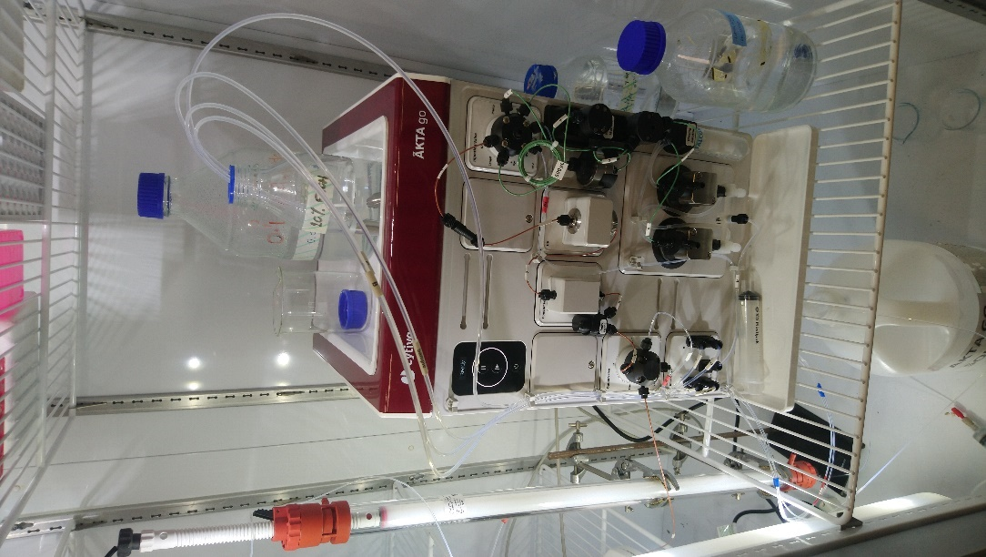

**Figure 3.** The Akta Go protein purification system available in the ACIS Wet lab.

**Safety:**

Hazards associated with this exercise and the Akta Go instrument are listed in the Risk Assessment Form available on LEARN.

As the majority of the samples purified with the system contain native or non-native proteins and other biomolecules, most are subject to Category 1 Biohazard regulations.

**Instrument Walk-Through:**

1. **Instrument Overview:**

* Familiarize users with the components of the Akta Go system, including the pumps, injector, column, detector, fraction collector and software interface.

2. **Safety Precautions:**

* Emphasise safety measures, including proper handling of solvents and chemicals. Remind users about the risks associated with any Category 1 Biohazards.
* Provide guidelines for using personal protective equipment, such as lab coats and safety glasses.

3. **Powering On and System Check:**

* Demonstrate the proper procedure for turning on the Akta Go system.
* Explain the how to check that the system is operating correctly, the pumps are working and that there are no detected leaks in the system.

4. **Sample Preparation:**

* Provide guidelines on choosing the appropriate solvents and sample compatibility with protein chromatography.
* Instruct users on sample preparation. Provide guidance on sample concentrations and prevention of insoluble material creating blockages.

5. **Column Selection and Installation:**

* Introduce the different types of protein purification columns and their applications. This should include size exclusion, ion exchange and affinity columns.
* Demonstrate the proper installation of the column, ensuring a secure and leak-free connection.

6. **Mobile Phase Preparation:**

* Instruct users on preparing mobile phases with the correct composition and pH.
* Emphasize the importance of using high-quality solvents to prevent contamination and remind users to make sure solvent reservoirs contain the required volume for each run.

7. **Method Development:**

* Discuss how to develop an efficient and robust chromatographic method.
* Discuss how to set parameters such as flow rate, gradient profile, detection wavelength and injection volume and the impact of these on chromatographic performance.

8. **Sample Submission and Fraction Collection:**

* Instruct users on how to submit samples, queue multiple samples and start a run.
* Set up the fraction collector to collect purified protein fractions.
* Define collection parameters based on peak detection or specific time intervals.

9. **Data Analysis:**

* Demonstrate how to interpret chromatograms including retention time, peak shape, and resolution. Use this information to help calculate the purity and yield of the purified protein.

10. **Shutdown Procedure:**

* Emphasize the importance of cleaning and flushing the system. Demonstrate how columns should be flushed and stored when not in use.

11. **Maintenance and Troubleshooting:**

* Offer guidance on common troubleshooting issues and when to contact the ACIS Instrument Technician. Common issues include leaks at either end of the installed column or solvent reservoirs running dry.

12. **Documentation:**

* Stress the importance of maintaining a detailed log of all runs, including method parameters, sample details, and obtained chromatograms. These should all be recorded in lab notebooks and any data copied over to personal devices via a USB memory stick.

**Test Samples:**

Test sample details – to be added.

**Assessment:**

Complete the associated multiple-choice quiz on LEARN.

**Further Support:**

The full instrument manuals are available on LEARN. You are not expected to read these in full, however, please use these as reference if you wish to know any more about the instruments or refresh your memory of how to operate them.

**Topic 3:** **Fluorescence and Circular Dichroism (CD) Spectroscopy**

**Learning Outcomes:**

* Explain the principle of Fluorescence Spectroscopy and Circular Dichroism (CD) Spectroscopy
* Compare and contrast these techniques with UV/Vis spectroscopy.
* Know how to operate a fluorescence spectrometer (or fluorimeter) – including sample preparation, spectral acquisition, lifetime measurements and data analysis.
* Know how to operate a Circular Dichroism (CD) spectrometer – including sample preparation, spectral acquisition and data analysis.
* Describe and troubleshoot common instrument failures.

**Pre-lab:**

Read through the information below **BEFORE** attending the associated lab session.

The fluorimeter utilises pulsed LASERS when acquiring lifetime measurements. Whilst the LASER is bolted to the instrument and protected by interlocks when in use, it can in theory be removed and changed over. Therefore, all users must complete the required School LASER safety training **BEFORE** using the instrument.

Links to the training can be found on LEARN.

**Introduction – Fluorescence Spectroscopy:**

Fluorescence spectroscopy is a powerful analytical technique used for exploring the interaction between light and fluorescent molecules, shedding light on their structure, composition, and dynamic behaviour. The ACIS lab is equipped with an Edinburgh Instruments FS5 fluorimeter.

Unlike UV/Vis spectroscopy, that explores only the absorption of light, fluorescence spectroscopy explores the absorption and emission of light from fluorescent samples. How much, for how long, and at what wavelength the light is emitted can provide valuable insights into the molecular environment. One of the main advantages of fluorimetry is its sensitivity – with most samples operating well into or below micromolar concentrations. This is primarily due to the fact that many compounds do not emit light, and therefore, there is considerably less background noise compared with other spectroscopic techniques.

Fluorescence spectroscopy can provide a huge amount of information on the electronic transitions within a compound. This is particularly important for the development of new photocatalysts and solar cell dyes where care must be taken to match energy levels. Fluorescence spectroscopy can also be used to explore the molecular environments due to the high distance dependence of many quenching or energy transfer process. This lends itself to many biological probes where fluorescent tags can used to explore protein folding pathways or detect specific process in live cells. The latter can be utilised with a Fluorescent plate reader to run biological assays – also available within the ACIS suite.

**Introduction – CD Spectroscopy:**

Circular Dichroism (CD) spectroscopy is an important technique for establishing the presence and ratio of any chiral structures within a compound. The ACIS lab is equipped with an Applied Photophysics Chirascan VX.

CD spectroscopy operates based on the differential absorption of left-handed (L) and right-handed (R) circularly polarized light by chiral molecules or structures. When circularly polarized light passes through an optically active sample, the absorption of L and R components occurs at slightly different wavelengths due to the molecule's interaction with the electromagnetic field. The CD spectrometer records this as a difference in absorption of L & R circularly polarized light at varying wavelengths – resulting in a CD spectrum, where positive and negative bands correspond to transitions associated with chiral electronic transitions. Because CD measures the difference in absorption, care must be taken to prepare samples at a suitable concentration where the change in absorption is easiest to detect.

As well as information about the enantiopurity of small organics, such as amino acids, CD spectroscopy can also provide valuable information about the secondary structure, conformational changes, and interactions of chiral substances such as proteins, nucleic acids, and molecular knots.

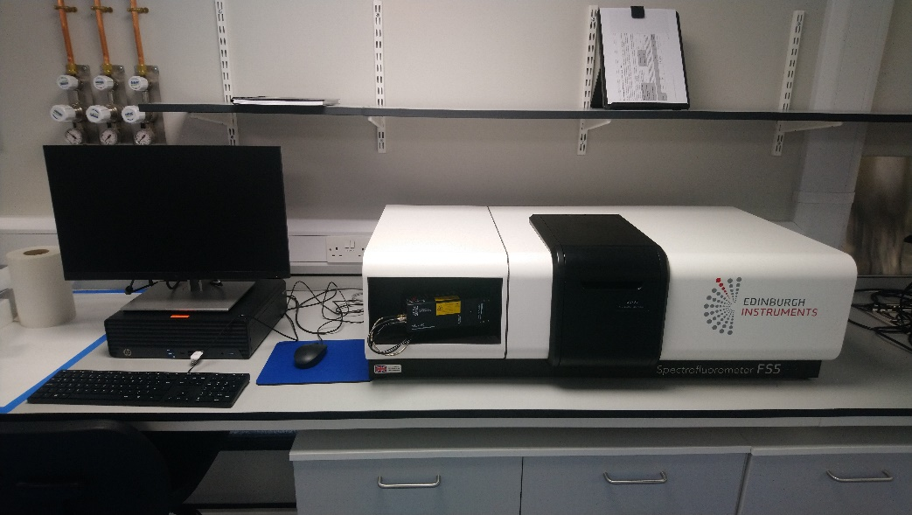

**Figure 4.** The Edinburgh Instruments FS5 Fluorescence spectrometer available in the ACIS lab.

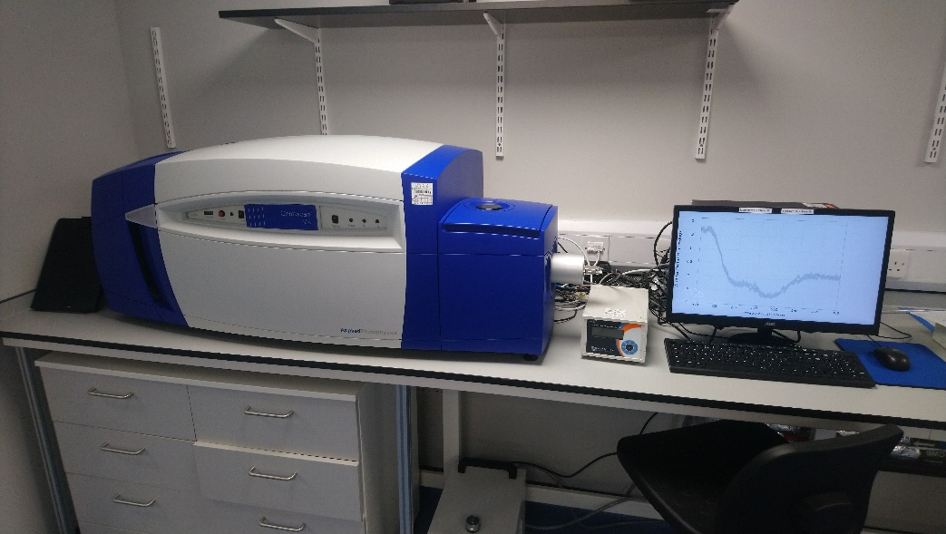

**Figure 5.** The Applied Photophysics Chirascan VX CD spectrometer available in the ACIS lab.

**Safety:**

Hazards associated with this exercise and the Fluorimeter and CD spectrometer are listed in the Risk Assessment Form available on LEARN.

The fluorimeter is fitted with a pulse LASER for lifetime measurements. Whilst the LASER is usually bolted to the instrument and protected by internal safety locks, it can technically be removed, and users must therefore complete the School LASER safety training **BEFORE** attending the lab.

The LASERs are not required for standard fluorescence measurements, but if required, they need turned on using a key. Please contact the ACIS instrument technician if you wish to carry out lifetime measurements in future.

**Instrument Walk-Through – Fluorimeter:**

1. **Instrument Overview:**

* Familiarize users with the components of the fluorimeter, including the sample chamber, LASER, excitation & emission filters and the software interface.
* Provide an overview of the theory behind fluorescence spectroscopy and the types of measurements that can be made.

2. **Safety Precautions:**

* Emphasise safety measures, including proper handling of solvents and chemicals.
* Provide guidelines for using personal protective equipment, such as lab coats and safety glasses.
* Confirm all users have completed the necessary LASER safety training.

3. **Powering On and System Check:**

* Demonstrate the proper sequence for turning on the instrument and time required to make sure the lamp and LASER are operating correctly.

4. **Sample Preparation:**

* Provide guidelines on choosing the appropriate solvents sample concentrations. The optical window of each solvent should be considered and absorbances kept below 0.1 A to avoid inner filter effects.
* Provide guidance on how to syringe filter samples to prevent any interference in the spectra.
* Provide guidance on correct cleaning procedures for the cuvettes. Rinse with a suitable solvent and dry with a lint free cloth. Clean thoroughly between samples and start with the lowest concentration is running calibration curves. Take care to handle cuvettes with gloves and hold them via the edges rather than faces where possible.

5. **Data Acquisition:**

* Instruct users on how to load samples into the holder and acquire blank spectra.
* Instruct users on how to set up and select an appropriate method including spectral width, slit widths, lamp switch over, number of data points, scan rate and any repetitions.
* Explain the difference between excitation and emission spectra.
* Discuss the use of excitation/emission filters and why they may be needed.

6. **Data Analysis:**

* Demonstrate how to interpret the spectra including peak maxima and total area.
* Discuss the presence of additional peaks including Raman/Rayleigh bands and second order diffraction.
* Explain how to export the data in multiple file formats.

7. **Shutdown Procedure:**

* Emphasize the importance of leaving the work area clean and tidy.
* Remind users to turn off the LASER if in use and return the keys to the ACIS instrument technician.

8. **Maintenance and Troubleshooting:**

* Offer guidance on common troubleshooting issues and when to contact the ACIS Instrument Technician. Common issues include non-zero baselines or excessive noise or interference due to dirty or contaminated samples. Significant non-linearity of emission intensity may also be observed for concentrated samples due to inner filter effects.

9. **Documentation:**

* Stress the importance of maintaining a detailed log of all fluorecence spectra, including method parameters, sample details, and obtained spectra. These details should all be recorded in lab notebooks and any data copied over to personal devices via a USB memory stick.

**Instrument Walk-Through – CD Spectrometer:**

1. **Instrument Overview:**

* Provide an overview of the principles of CD spectroscopy including the basics of circularly polarized light and how it interacts with chiral molecules.
* A discussion on the applications of CD spectroscopy in studying biomolecules.
* Introduce the components of the CD spectrometer, including the light source, sample compartment, monochromators, and detectors.

2. **Safety Precautions:**

* Emphasise safety measures, including proper handling of solvents and chemicals.
* Provide guidelines for using personal protective equipment, such as lab coats and safety glasses.

3. **Powering On and System Check:**

* Demonstrate the proper sequence for turning on the instrument and time required to make sure the lamp is operating correctly.
* Explain how and why a constant flow of N2 gas must be maintained when the instrument lamp is on to prevent the build-up of ozone.

4. **Sample Preparation:**

* Provide guidelines on choosing the appropriate solvents sample concentrations. The optical window of each solvent should be considered and absorbances kept below 1 A.
* Provide guidance on how to syringe filter samples to prevent any interference in the spectra.
* Provide guidance on correct cleaning procedures for the cuvettes. Rinse with a suitable solvent and dry with a lint free cloth. Clean thoroughly between samples and start with the lowest concentration is running calibration curves.

5. **Data Acquisition:**

* Instruct users on how to load samples into the holder and acquire blank spectra.
* Instruct users on how to set up and select an appropriate method including spectral width, slit widths, lamp switch over, number of data points, scan rate and any repetitions.

6. **Data Analysis:**

* Demonstrate how to interpret the spectra including suitable units and smoothing functions.
* Explain how to export the data in multiple file formats.

7. **Shutdown Procedure:**

* Emphasize the importance of leaving the work area clean and tidy.
* Remind users to turn off the N2 gas supply after shutting down the lamp.

8. **Maintenance and Troubleshooting:**

* Offer guidance on common troubleshooting issues and when to contact the ACIS Instrument Technician. Common issues include non-zero baselines or excessive noise or interference due to dirty or contaminated samples.

9. **Documentation:**

* Stress the importance of maintaining a detailed log of all CD spectra, including method parameters, sample details, and obtained spectra. These details should all be recorded in lab notebooks and any data copied over to personal devices via a USB memory stick.

**Test Samples:**

Test sample details – to be added.

**Assessment:**

Complete the associated multiple-choice quiz on LEARN.

**Further Support:**

The full instrument manuals are available on LEARN. You are not expected to read these in full, however, please use these as reference if you wish to know any more about the instruments or refresh your memory of how to operate them.

**Topic 4: Nuclear Magnetic Resonance (NMR) Spectroscopy**

**Learning Outcomes:**

* Explain the principles of NMR spectroscopy.
* Compare and contrast different NMR instruments and identify which instruments are most suitable for each experiment.
* Know how to operate an NMR instrument in automation – including sample preparation, sample submission and data analysis.
* Describe and troubleshoot common instrument failures.

**Pre-lab:**

This experiment will involve official training to allow you submit your own NMR samples during your investigation B and summer project. To do so, you must complete the required online training **BEFORE** attending this lab session.

Please refer to LEARN for all of the required information and links to the training materials.

**Introduction:**

Nuclear Magnetic Resonance Spectroscopy (NMR) is a powerful analytical technique used for the identification and quantification of pure compounds and complex mixtures. The School of Chemistry is fortunate to be equipped with a dedicated NMR suite including the following instruments.

* 1 x 300 MHz solid-state instrument equipped with a 4 mm WB MAS broadband probe, available for 13C, 15N, 31P, 11B and various X nuclei, with spin rates of up to 12.5 kHz.
* 1 x 400 MHz instrument (AVA400) equipped with a TBO room temperature probe available for 1H and all X nuclei.
* 2 x 500 MHz instrument. One (PRO500) is equipped with a broad band Prodigy cryo-probe and available for 1H and all X nuclei. The other (AVA 500) is equipped with a BBO cryoprobe available for 1H and all X nuclei.
* 1 x 600 MHz instrument equipped with a QCI cryo-probe and available for 1H, 13C, 15N and 19F only.
* 1 x 800 MHz instrument equipped with multiple probes that are changed occasionally. The most regular is a TCI cryoprobe available for 1H, 13C and 15N only. This instrument usually reserved for specialist samples including protein structure elucidation and the analysis of complex mixtures.

Many of you will already have completed the NMR introductory courses and workshops in Semester 1, but in summary, NMR is a powerful technique for elucidating the structure of compounds in solution. By applying a strong magnetic field, all nuclei with spin ≠ 0 are placed into two or more possible states. As a form of spectroscopy, the application of radio frequencies then allows us to probe the differences in these energy levels. Since the energy differences experienced by the nuclei are small and highly dependent on their local environment, this allows us to extract a lot of information about the chemical structures.

NMR is inherently a very insensitive technique. However, modern methods and powerful magnets have developed NMR into one of the key analytical techniques for many chemists. To achieve this does require some specialist sample preparation – including specific sample tubes, deuterated solvents, and reasonably high concentrations.

**Figure 6.** The School of Chemistry NMR suite.

**Safety:**

Hazards associated with this exercise and the NMR instruments are listed in the Risk Assessment Form available on LEARN.

Please note, the instruments operated during this lab contain very strong magnetic fields. Your demonstrator will advise further on the day, but please avoid taking any metallic objects close to the instruments – this includes watches, keys and credit cards.

**If you have any medical devices or implants – such as pacemakers, hearing aids or metal pins – please alert your demonstrator to this as soon as you can and do not enter the NMR room.**

**Instrument Walk-Through:**

1. **Instrument Overview:**

* Familiarize users with the components of the NMR system, including the magnet, probe, console, sample loader and the software interface.
* Introduce the different types of NMR instruments and their applications.
* Talk through the NMR information board, and how to choose the best instrument for the task. NOTE: NMR suite closed every Wednesday morning for liquid nitrogen refills.

2. **Safety Precautions:**

* Emphasize safety measures, including proper handling of solvents, chemicals and cryogens.
* Remind students of the dangers associated with strong magnetic fields.
* Provide guidelines for using personal protective equipment including wearing safety glasses when submitting or retrieving samples. No lab coats are to be worn in the NMR suite.

3. **Sample Preparation:**

* Provide guidelines on choosing the appropriate solvents and concentrations for NMR.
* Instruct users on sample preparation including correct tube fill levels and advice on the effects and removal of undissolved solids.
* Show how to place sample tubes within the correct spinner and level them appropriately. NOTE: take care here, incorrect sample levelling is the number one cause of serious instrument malfunctions and damage.

4. **Sample Submission:**

* Run through the sample submission process including logging in, sample position selector, solvent and experiment selection, night/day experiments and user details.
* Demonstrate how to place the sample in the sample holder.
* Explain how to remove any other completed samples from the holder and where to place them in the sample racks.

5. **Data Analysis:**

* Provide training on using the NMR software for data acquisition.
* Demonstrate how to interpret the NMR data, including peak position, peak integrals and splitting patterns using the TopSpin software. Students should be familiar with MNova, but additional guidance on this software is available on LEARN if required.

6. **Logging Off procedure:**

* Remind users to log off after submitting.
* Please leave the area clear of any samples, tissues and put away any spinners or samples taken out of the instrument.

7. **Maintenance and Troubleshooting:**

* Offer guidance on common troubleshooting issues and when to contact the NMR Technicians using the bell provided. Common issues include using o-rings to secure sliding tubes, DMSO freezing and the use of Young’s tap NMR tubes.

8. **Documentation:**

* Stress the importance of maintaining a detailed record of NMR samples run, including sample details and acquired spectra. These should be recorded in lab notebooks and any data copied over to personal devices from the NMR archive.

**Test Samples:**

Test sample details – to be added.

**Assessment:**

Complete the associated multiple-choice quiz on LEARN.

**Further Support:**

Further information on the theory and uses of NMR can be found in the notes from the Semester 1 Introduction to NMR course. Advice and guidance on downloading and using the NMR software MNova can be found on LEARN.

**Computational Exercise**

**Learning Outcomes:**

* Understanding of the practical aspects of molecular simulations.
* Basics of the command-line interface and usage high-performance computing resources.
* Operating common computational chemistry packages to tackle real chemical problems.
* Preparation of systems for molecular dynamics simulations and troubleshooting the set up, simulations and analysis steps.
* Understanding of the limitations of the computational chemistry techniques used.
* Reporting of the methodology and observations in a condensed written format.
* Group working, encouraged and developed through the practicals.

Computational techniques have become an integral part of the research, with their importance and contribution to scientific discovery growing rapidly in recent years. The use of computational techniques in chemistry has made it possible to simulate chemical reactions and predict the properties of molecules with a high degree of accuracy. Additionally, molecular simulations have made it possible to study complex systems that are difficult, if not impossible, to study experimentally, such as large protein complexes, biological membranes, interactions of molecules and materials at the interface, processes in space or in extreme conditions. These methods have had a positive impact on society by accelerating the development of new drugs, materials, and technologies. Therefore, it is essential for students to have a solid understanding of computational techniques and their applications in modern scientific methods. This part of the course, focuses on molecular dynamics simulations, one of the most commonly used methodologies in current research.

**Content:**

Session 1: Introduction to Linux and command-line.

Session 2: Introduction to molecular dynamics simulations on a practical simulation of a protein.

Session 3: Molecular simulation set up of system with an interface.

Session 4: Beginning of the individual projects.

**All the materials for the sessions are provided on LEARN.**

**Drop-in sessions:**

Weekly drop-in sessions with demonstrators are scheduled for ….

**Assessment:**

Individual project with a short, written report. The report structure can be found on LEARN.**Investigation B: Synthesis and Evaluation of Acetylcholinesterase Inhibitors**

**1. Introduction**

Acetylcholinesterase (AChE) is a key enzyme in biological nerve conduction between cholinergic synapses. AChE can hydrolyse acetylcholine (ACh), terminate the excitatory effect of neurotransmitters on the postsynaptic membranes, and play an important role in regulating the transmission of nerve signals in organisms.1 Acetylcholinesterase inhibitors (AChEIs) can effectively increase the level of ACh by inhibiting AChE and are mainly used to treat Alzheimer’s disease (AD) clinically.2 Until now, there are numbers of AChEIs approved by FDA, such as rivastigmine,3 tacrine,4 and donepezil.5



In this investigation, you will synthesis Tacrine (9-amino-1,2,3,4-tetrahydroacridine). This was the first drug approved by the US FDA for the treatment of mild to moderate AD in 1993. The synthesis of Tacrine should be possible in 1-2 steps using appropriate reagents and methods. An obvious place to try to discover new analogues of Tacrine is by modification at the aniline nitrogen (remember – anilines are generally avoided in drug molecules). Moreover, there are well-established assays and commercial kits to test the inhibitory activity of compounds against AChE as it is a well-studied enzyme. Importantly, abundant crystal structure sources of AChE are available on the PDB website (http://www.rcsb.org/), which can be useful for molecule docking experiments. Therefore, tacrine is the target molecule in this research-based experiment.

**References**

1. Soreq, H.; Seidman, S. Acetylcholinesterase-new roles for an old actor. *Nat. Rev. Neurosci*. 2001, **2**, 294– 302, DOI: 10.1038/35067589
2. Anand, P.; Singh, B. A review on cholinesterase inhibitors for Alzheimer’s disease. *Arch. Pharmacal Res*. 2013, **36**, 375– 399, DOI: 10.1007/s12272-013-0036-3
3. Lipp, L.; Sharma, D.; Banerjee, A.; Singh, J. In vitro and in vivo optimization of phase sensitive smart polymer for controlled delivery of rivastigmine for treatment of Alzheimer’s disease. *Pharm. Res*. 2020, **37**, 34, DOI: 10.1007/s11095-020-2757-6
4. Svobodova, B.; Mezeiova, E.; Hepnarova, V.; Hrabinova, M.; Muckova, L.; Kobrlova, T.; Jun, D.; Soukup, O.; Jimeno, M. L.; Marco-Contelles, J.; Korabecny, J. Exploring structure-activity relationship in tacrine-squaramide derivatives as potent cholinesterase inhibitors. *Biomolecules* 2019, **9**, 379, DOI: 10.3390/biom9080379
5. Cui, X.; Guo, Y. E.; Fang, J. H.; Shi, C. J.; Suo, N.; Zhang, R.; Xie, X. Donepezil, a drug for Alzheimer’s disease, promotes oligodendrocyte generation and remyelination. *Acta Pharmacol. Sin*. 2019, **40**, 1386–1393, DOI: 10.1038/s41401-018-0206-4

**2. Timetable**

??

**3. Investigation Aims**

Working in your assigned groups, you will need to design and carry out experiments and procedures to complete the following aims:

***Aim 1****: Synthesise, purify and characterise Tacrine and four Tacrine analogues.*

***Aim 2:*** *Perform acetylcholinesterase inhibition assays to determine the activity of Tacrine and Tacrine analogues.*

***Aim 3:*** *Analyse the structure-activity relationships and ‘drug-like’ properties.*

***Aim 1 – Synthesis, purification and characterisation of Tacrine and four Tacrine analogues – expected time 2-3 weeks.***

*You will be required to search the chemical literature to find suitable methods for the synthesis of Tacrine and then the preparation of four N-acylated analogues of Tacrine.* For the N-acyl Tacrine analogues, you should design a hypothesis that you will test e.g. the effect of chain homologation or branching on inhibitory activity. Each of the compounds should be purified (if required) by e.g. recrystallisation or column chromatography and characterised using at least 2 appropriate analytical methods. You should calculate isolated percentage yields. You should also propose the mechanisms for each step of the synthesis.

**Note** – reagents including 2-aminobenzonitrile (CAS: 1885-29-6), cyclohexanone (CAS: 108-94-1), some simple acyl chlorides and standard reagents and solvents will be available in the laboratory.

***Aim 2 – Perform acetylcholinesterase inhibition assays to determine the activity of Tacrine and Tacrine analogues – expected time 1-2 weeks.***

You will be provided with an acetylcholinesterase inhibition assay kit. You should read and understand the instructions (please check with a demonstrator if you don’t understand). Measure the inhibitory activity of the synthesised tacrine and acylated tacrine against AChE by measuring absorbance at 412 nm for different analogue concentrations in a plate reader (ACIS or 4P lab). Use e.g. GraphPad Prism 7 (or other similar software) to plot a dose-response relationship and fit the inhibition curve of the log of the compound concentration and measured AChE activity to estimate the IC50 for each compound.

General Procedure for Enzyme Activity Assay

Note: This assay is based on an enzyme-catalyzed kinetic reaction. Addition of Working Reagent should be quick, and mixing should be brief but thorough. The total assay volume (buffer + substrate + enzyme + inhibitor) should be held constant at 200 μL.

Accurate pipetting is very important to achieve good data!

1. Dissolve 0.1 mmol tacrine or acetylated tacrine with 0.5 ml DMSO to obtain a 2×10-1 M drug solution. Dilute with PBS to obtain 2×10-2, 2×10-3, 2×10-4, 2×10-5, 2×10-6, 2×10-7, 2×10-8 M solutions respectively.
2. Dilute AChE (18 mg) with PBS (pH=7.4, 0.1% BSA) to 900 μL, store at 0-4 °C.
3. Take 90 μL of the AChE solution and add 10 μL of the corresponding concentration of the drug. The final concentration of the drug is 2×10-3, 2×10-4, 2×10-5, 2×10-6, 2×10-7, 2×10-8, 2×10-9, 0 (1% DMSO) M. Inhibit enzyme for 15 min.
4. Add 1.8 mL of Assay Buffer and 18 mg of Reagent and vortex to dissolve. Cover with

parafilm and mix gently by inversion. The Working Reagent should be prepared fresh and used within 30 minutes.

5. Transfer 200 mL of water (Assay Blank) and 200 mL of Calibrator into separate wells of

a 96 well plate. Add 10 mL of samples into separate wells of the 96-well plate.

6. Transfer 190 mL of the freshly prepared Working Reagent to all sample wells and tap

plate briefly to mix.

7. Incubate the samples at room temperature. After 2 minutes, take the initial absorbance

measurement at 412 nm (A412)initial.

8. Continue to incubate the plate at room temperature. At 10 minutes, take the final

measurement (A412)final.

9. AChE activity (units/L) = [((A412)final - (A412)initial)/( (A412)calibrator - (A412)blank)]×200

200 = equivalent activity (units/L) of Calibrator when assay read at 2 min & 10 min

(A412)calibrator = Absorbance of the calibrator at 10 min

(A412)blank = Absorbance of the blank at 10 min

10. Inhibition% = (B-S)×100/B

S = enzyme activity value of the inhibitory enzyme group

B = enzyme activity value of the control group

11. GraphPad Prism 7 software was used to fit the inhibition curve, and IC50 was determined by non-linear fitting using the standard IC50 equation: %Activity = 100*IC50/(IC50+[Ox]).

**Notes on AChE Inhibition Assays**

The AChE activity will be measured using a commercial kit, the acetylcholinesterase activity assay kit, developed according to the Ellman’s spectrophotometrical method. Acetylthiocholine iodide (ATCh) is an analogue of ACh that can be hydrolysed by AChE to produce acetic acid and thiocholine iodide (TCh) (Reaction A). TCh can react with 5,5′-dithiodis-2-nitrobenzoic acid (DTNB) rapidly and quantitatively to form a yellow anion 5-thio-2-nitrobenzoic acid (RS–) with maximum absorption at 412 nm wavelength (Reaction B). The TCh generated by quantification of the final generated RS– is measured by absorbance (OD) to calculate the activity of AChE.



***Aim 3: Analysis of structure-activity relationships and ‘drug-like’ properties - expected time 1 week.***

As a group you should discuss the results that you have obtained from your acetylcholinesterase assays to determine how the structural changes have affected the enzyme inhibition. Does this agree with your hypothesis? It is suggested that you use computer software packages to try to explain the observations – you may consider using PyMol, for example.

It's worth remembering that acetylcholinesterase inhibitors work at CNS targets, so would need to access the brain – how do the properties fit with those generally regarded to be required for CNS-penetration? You should be able to predict some key properties using software packages, such as ChemDraw or websites such as Molinspiration.

***Note – you must plan your time and roles within the team carefully in order to complete all of the required aims.***

Once complete, each student should write up and submit AN INDIVIDUAL REPORT BASED ON THE FINDINGS FROM YOUR GROUP.

**Hazards for some possible reagents (not comprehensive)**

*Cyclohexanone* exhibits slight toxic properties such as anaesthesia and causticity.

*Zinc chloride* is highly toxic and can irritate and burn skin and mucous membranes violently.

*2-Aminobenzonitrile* can cause skin, eye, and respiratory irritation.

*Sodium hydroxide* (NaOH) will release a lot of heat when it meets water, forming a strong corrosive solution.

*Hexane* is flammable and toxic (neurotoxin).

*CHCl3 and CDCl3* have an anaesthetic effect, and they are all potential carcinogens.

*Acetyl chloride* is irritating to the upper respiratory tract and causes coughing and chest pain after inhalation. It will react violently or even explode when it meets water, water vapor, and ethanol.

*DMSO* is known to rapidly penetrate and burn the skin and to cause a tingling sensation.

Therefore, protective measures should be taken throughout the experiment, and operation should be performed strictly in the fume hood; students should wear experimental clothes, gloves, and goggles at all times. If the skin or eyes accidentally come into contact with these reagents, wash immediately with plenty of water.

**3. The Laboratory**

You will be based within the Lyon Playfair lab (Christina Miller Building, Ground Floor). You will be assigned a PhD Demonstrator to oversee your work, answer any questions you might have and ensure your safety whilst working within the laboratory. You can also contact the lab technician (Stewart Franklin) if you require any assistance with additional chemicals or equipment.

You will also have access to the School’s analytical facilities, including NMR, Mass Spec and the ACIS lab. Please discuss any sample submissions with your PhD demonstrator. The ACIS Technician Alba Navanno Rodriguez (??) can assist with any instruments required in the ACIS lab – this includes the plate reader required for

**4. Available Analytical Techniques**

The School of Chemistry has a wealth of world class instruments and analytical facilities. You will have access to the following instrumentation and services to aid you in the identification and quantification of unknown substances.

Note that the collection of data for poorly prepared samples will not be tolerated due to the risk these samples might pose to the instruments. Take care to prepare samples according to guidelines and ask for assistance if in doubt.

The running of any spectroscopic samples should be cleared with your demonstrator beforehand to ensure that service time is being used appropriately. Your demonstrator will be able to offer advice on how to access/use appropriate services.

*NMR Spectroscopy:*

1H and 13C NMR techniques as well as common 2D spectroscopic methods. Extensive structural information available for simple organics, but analysis far easier in conjunction with other analytical techniques.

*Mass Spectrometry:*

ESI or EI ionisation techniques and accurate mass determination. Used to confirm the chemical formula of an unknown compound.

*IR Spectroscopy (ATR – Attenuated Total Reflectance):*

This can be used to either identify a pure compound based on its IR fingerprint and known databases or quantify mixtures if IR spectra of individual components are known. However, for unknown compounds, its primary purpose is to identify functional groups.

*Ultra High & High Performance Liquid Chromatography (UPLC/HPLC):*

Allows the separation and quantification of compounds. Can be coupled to a mass spectrometer or other suitable detectors.

*Melting Point Apparatus:*

Melting point determination of pure compounds. Results can be matched to expected literature values.

*UV/Vis and Fluorescence Spectrometry:*

The ACIS lab is equipped with fluorescence spectrometer and UV/Vis instruments can be found in the Lyon Playfair laboratory. Both can be used for quantification of purified known compounds and analysis of spectral properties.

*Plate Reader:*

A system for the analysis of 96-well plates for the rapid evaluation of reaction screens or enzyme assays. Detection usually performed with either UV/Vis absorption or fluorescence.

**5. Report Structure**

The report for this investigation will be submitted as a formatted paper in the standard Royal Society of Chemistry (RSC) journal format – specifically for the journal [Chemical Communications](https://pubs.rsc.org/en/journals/journalissues/cc#!recentarticles&adv). This gives you the opportunity to write out your results as you would do if submitting novel research for publication in a peer-reviewed journal. Appendix A below contains a version of the official journal template for reference, but you can download an editable version from LEARN or at the following website:

[https://www.rsc.org/journals-books-databases/author-and-reviewer-hub/authors-information/prepare-and-format/article-templates/#microsoftword](https://www.rsc.org/journals-books-databases/author-and-reviewer-hub/authors-information/prepare-and-format/article-templates/%23microsoftword)

Remember, the purpose of a scientific paper is to present a solution to an identified problem. You should present an aim or hypothesis, describe the experiments and results carried out, and discuss how the data either completes the aim or backs up the hypothesis.

You can find many examples of how to present your data by simply going to the Chemical Communications journal website and looking through some of the recent articles.

In line with the journal protocol, you should only present data directly related to the discussion within the main body of the paper. Any other extended experimental details (methods, additional spectra, calculations etc) should be provided within the Supporting Information. For the purposes of marking, you should combine your paper with the Supporting information into a single .pdf file before submission.

**FAQs**

1. **Who should I list as an author?**

Whilst you will be carrying out the work in groups, the report is still presented as a piece of individual work. You can simply list yourself as the only author.

1. **Is there a word limit for the report?**

There is no specific word limit for the paper, but is should be no more than 4 pages in length. The supporting information has no specific maximum length but it should only include information directly relevant to the paper’s content. Marks will be deducted for extended versions containing irrelevant results.

1. **Should I provide a graphical abstract?**

No, but you should include the standard written abstract within the template.

Received 00th January 20xx,

1. Address here.
2. Address here.
3. Address here.

† Footnotes relating to the title and/or authors should appear here.

Electronic Supplementary Information (ESI) available: [details of any supplementary information available should be included here]. See DOI: 10.1039/x0xx00000x

Accepted 00th January 20xx

DOI: 10.1039/x0xx00000x

Title

Author Full Name,*a Author Full Name b and Author Full Name c

Abstract here. The abstract should be a single paragraph which summarises the content of the article. It should be no longer than 50 words (approximately 5-6 lines).

The main text of the article should appear here. Headings and subheadings are not permitted in articles submitted to *Chemical Communications*, with the exception of “**Conflicts of interest**” and “**Notes and references**”. Headings are permitted in communications submitted to other journals.

Conclusions

The conclusions section should come in this section at the end of the article. Please remove the “**Conclusions**” heading for articles submitted to *Chemical Communications*.

Author Contributions

We strongly encourage authors to include author contributions and recommend using [CRediT](https://credit.niso.org/) for standardised contribution descriptions. Please refer to our general [author guidelines](https://www.rsc.org/journals-books-databases/journal-authors-reviewers/author-responsibilities/) for more information about authorship. Please remove the “**Author Contributions**” heading for articles submitted to *Chemical Communications*.

Conflicts of interest

In accordance with our policy on [Conflicts of interest](http://www.rsc.org/journals-books-databases/journal-authors-reviewers/author-responsibilities/#code-of-conduct) please ensure that a conflicts of interest statement is included in your manuscript here.  Please note that this statement is required for all submitted manuscripts.  If no conflicts exist, please state that “There are no conflicts to declare”.

Notes and references

‡ Footnotes relating to the main text should appear here. These might include comments relevant to but not central to the matter under discussion, limited experimental and spectral data, and crystallographic data.

§

§§

etc.

1. Citations should appear here in the format A. Name, B. Name and C. Name, *Journal Title*, 2000, **35**, 3523; A. Name, B. Name and C. Name, *Journal Title*, 2000, **35**, 3523.
2. …

We encourage the citation of primary research over review articles, where appropriate, in order to give credit to those who first reported a finding. [Find out more](https://www.rsc.org/news-events/articles/2020/jun/rsc-signs-dora/) about our commitments to the principles of San Francisco Declaration on Research Assessment (DORA).

Formatting – please delete this box prior to submission

* Our template aims to give you an idea of what your article will look like, however the final version will be formatted in our house style and may look different.
* Please consult the Styles menu for recommended formatting for all text, including footnotes, references, tables, images and captions.
* Text should not be wrapped around graphics.
* *Chemical Communications* has a four page limit, therefore following editing and production, your article may require shortening. To assist with this please do not alter font sizes from the Styles menu.

During production:

* Graphics, including tables, will be located at the top or bottom of the column following their first citation in the text. Graphics can be single column or double column as appropriate and require captions.
* Equations will be placed in the flow of the text.
* Sufficient space will be inserted around graphics for clarity of reading; a horizontal bar will also be used to separate all inserted graphics, tables and their captions from the text.

If you are experiencing difficulty using our template, please consult our ‘Using the Template’ guide, found [here](https://www.rsc.org/journals-books-databases/author-and-reviewer-hub/authors-information/prepare-and-format/article-templates/).